This is just the quintessential Mains Interlock that meets a SEMI requirement “SOP39”, this being a subset of S2-0300 and includes EN61010-1. The front side is not shown, but has large double circuit breaker, start pushbutton, and some power indicator lamps etc. Significant with this Interlock was the rigid dimensional requirements. With very limited space on the front of the tool, this enclosure needed to be very narrow and not too tall. Cooling is through the top cover with lots of ventilation holes.
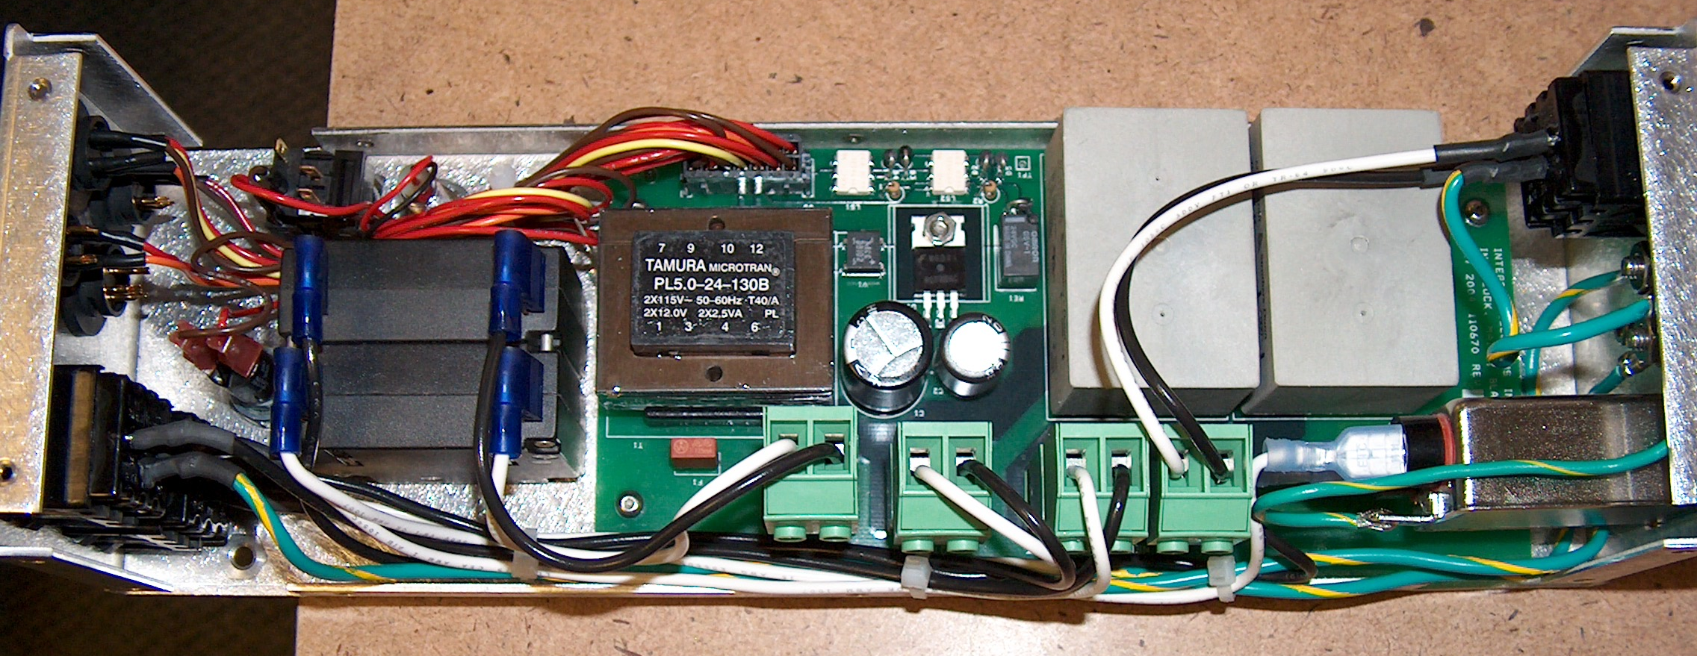

Any Mains Interlock needs a power input and it must be done just right to meet safety requirements.
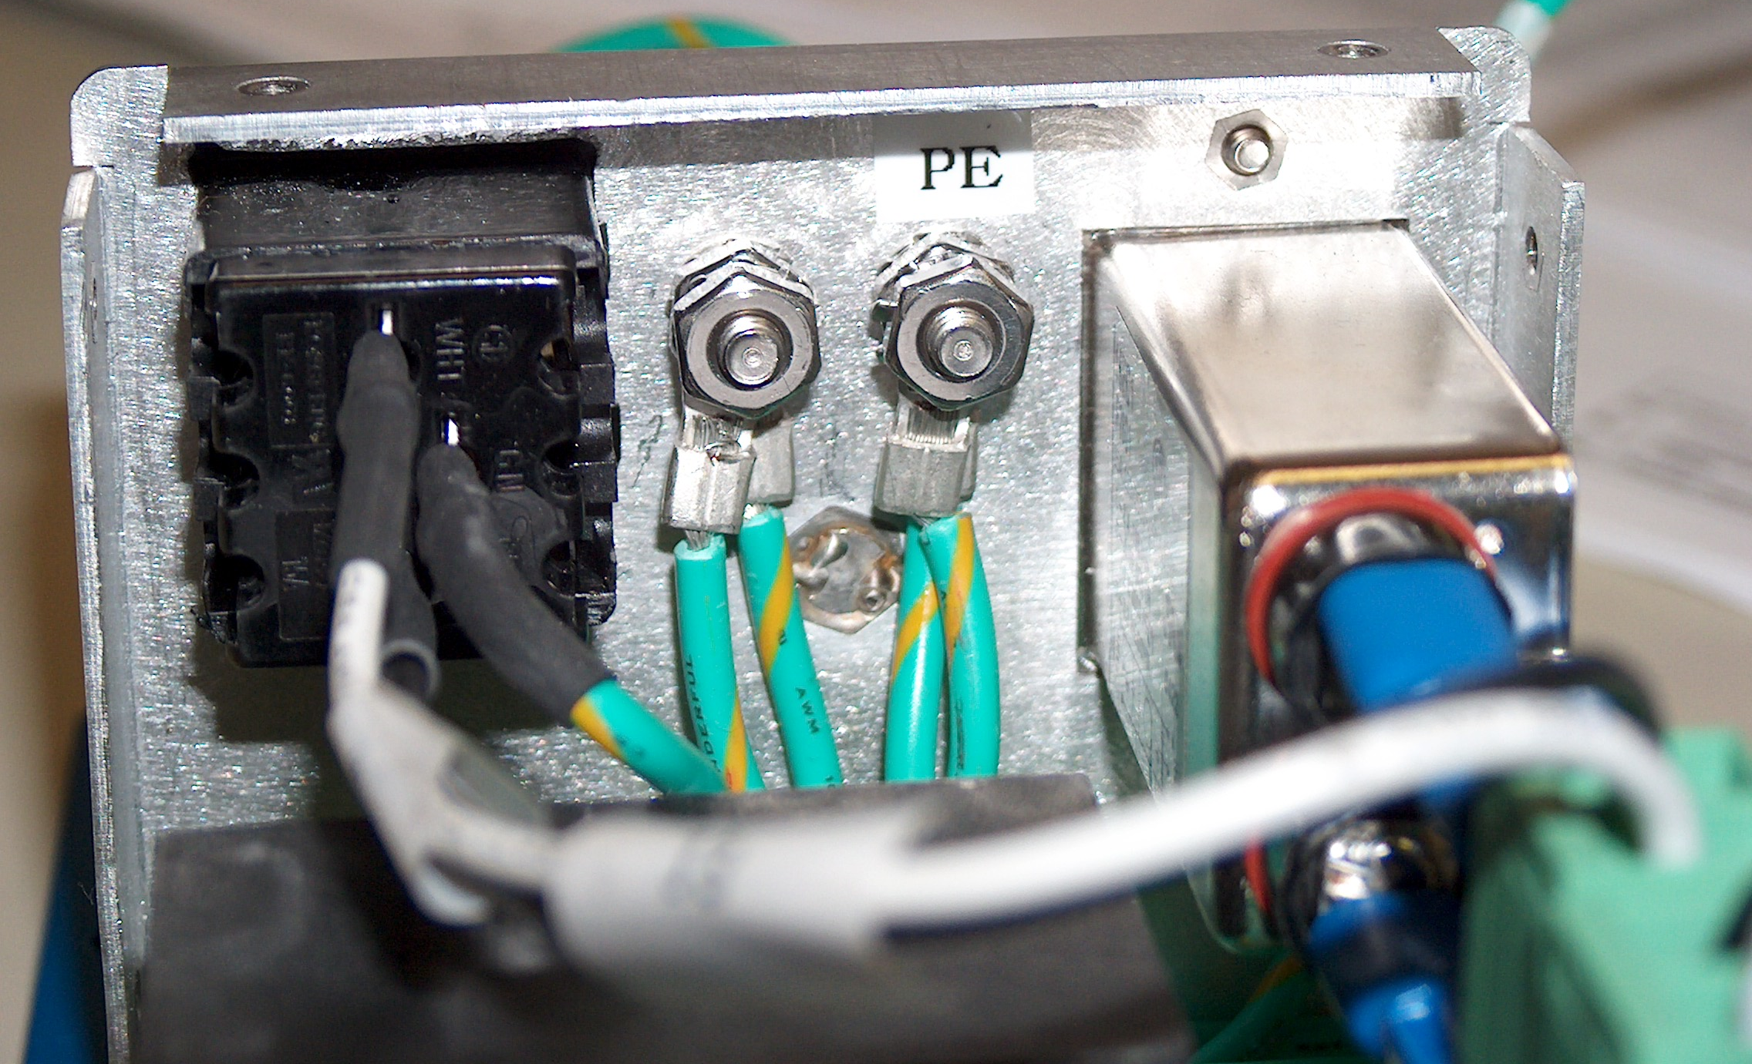
Below the “Primary Earth” ground is an external pressed in 8X32 threaded stud that provides the “System Ground”.

Some big customers of SEMI Capital Equipment have banned fixed power cords and so a Power Entry Module was used. A second fused PEM on the back of the machine supplied AC power.
This tool had a door to an enclosed area where motion occurred. When the door was open the motion AC power would be switched off independent of the EMO. During an EMO, both outlets would be switched off. The circular connectors are for digital status logic of Door and EMO switches. Also EMO and door switch connections.
