This subsystem starts out as a standard Bi-polar magnet linear power supply. To drive a TE Cooler / Heater it is modified slightly. But basically an OEM temperature controller is installed in the front panel. Additional back panel connections are made for RTD signals.
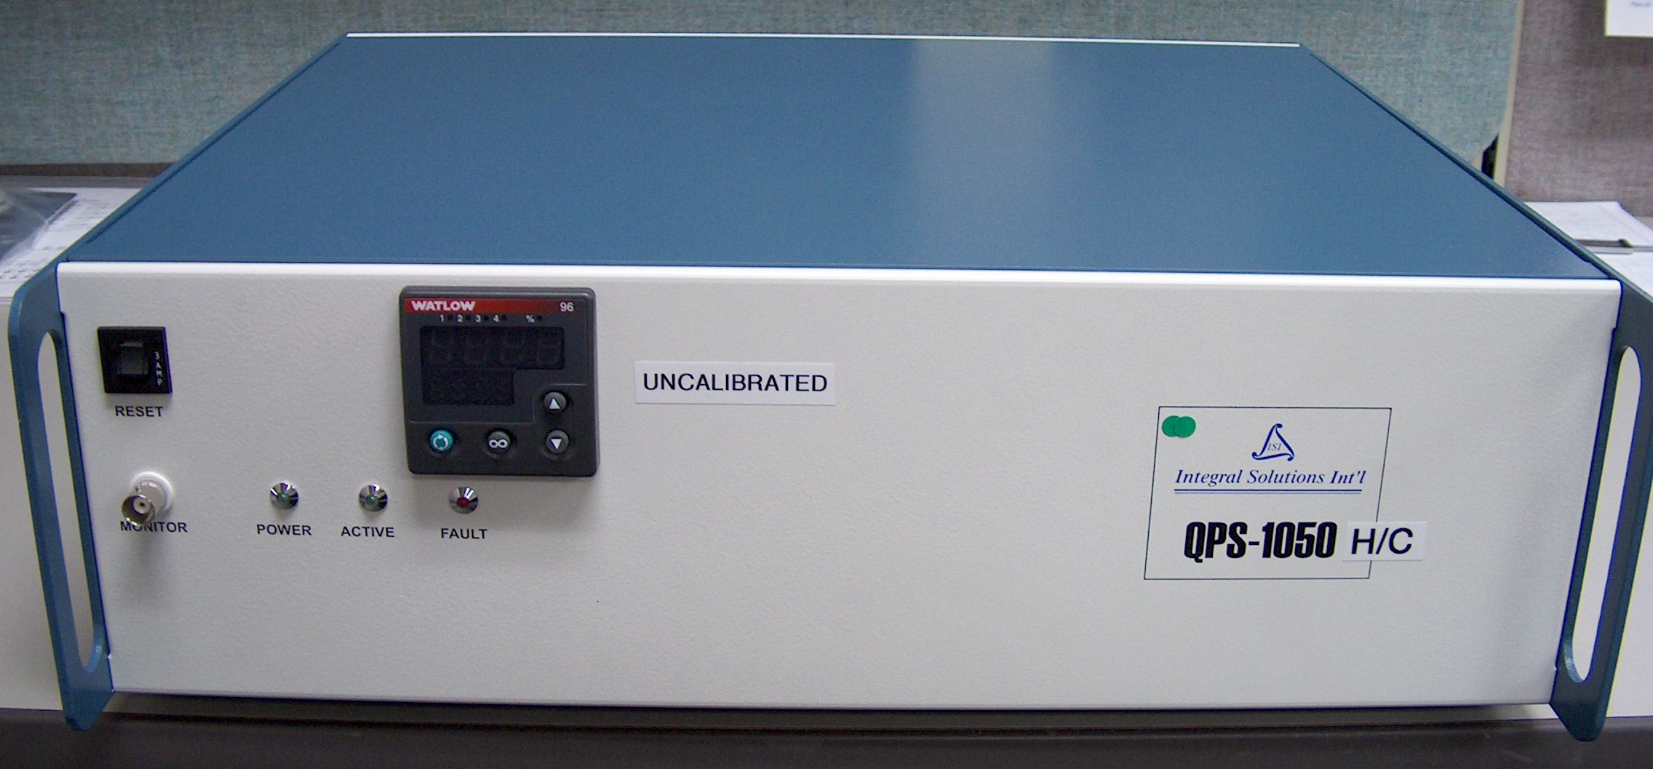
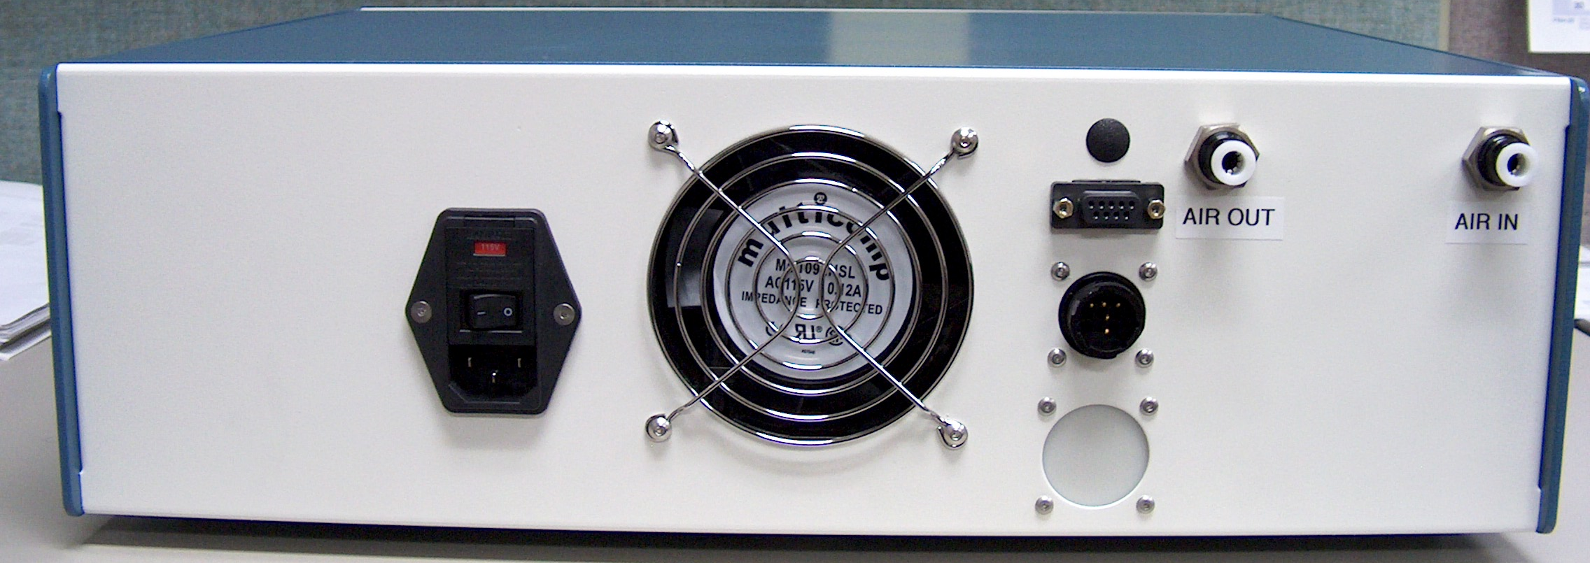
The OEM temp controller has an internal switching power supply that radiates a lot of noise. It is easily by-passed and the sub-system supplies the power.
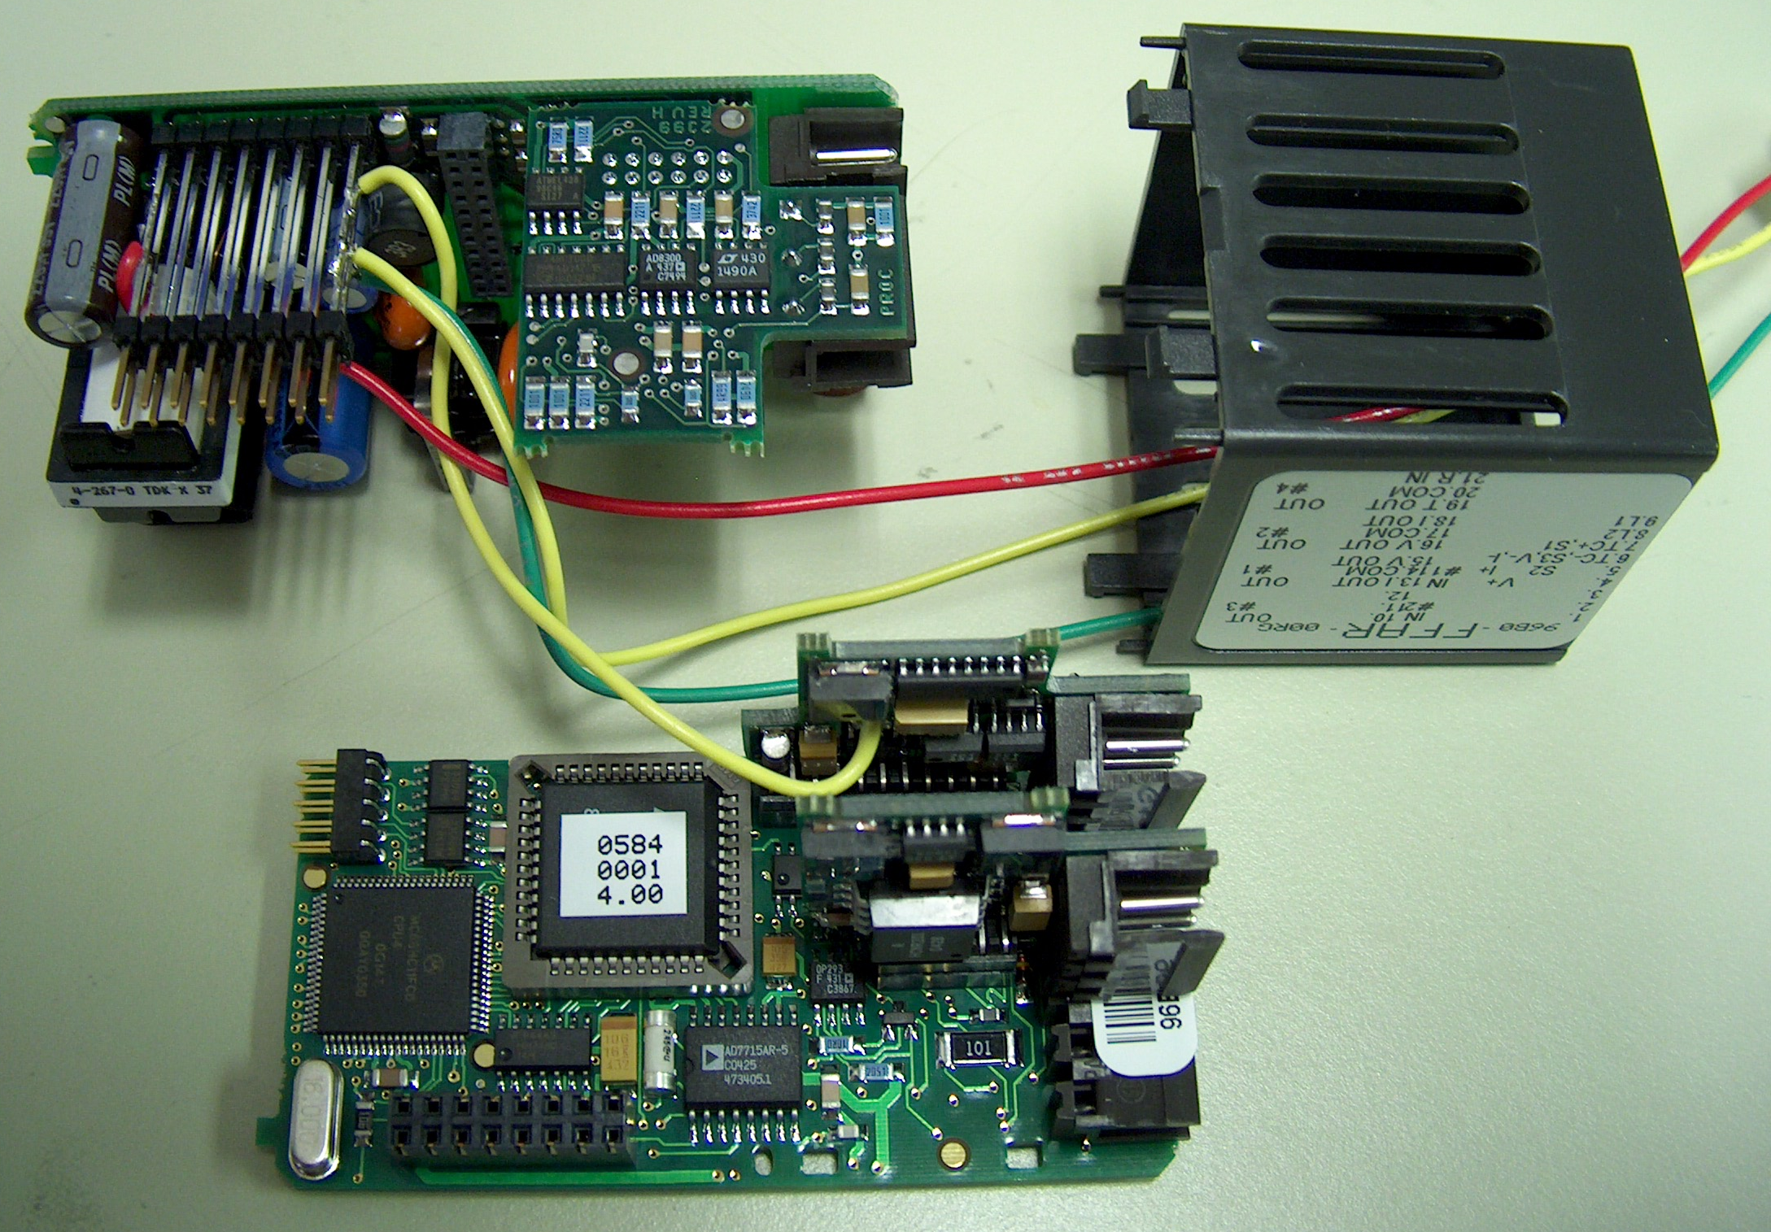
The temp controller’s hot and cold outputs are separate and high impedance. I made a small board (not shown) to buffer and convert to bi-polar.
This shows where the R/W Heads contact the thermal shoe containing the TE and RTD.
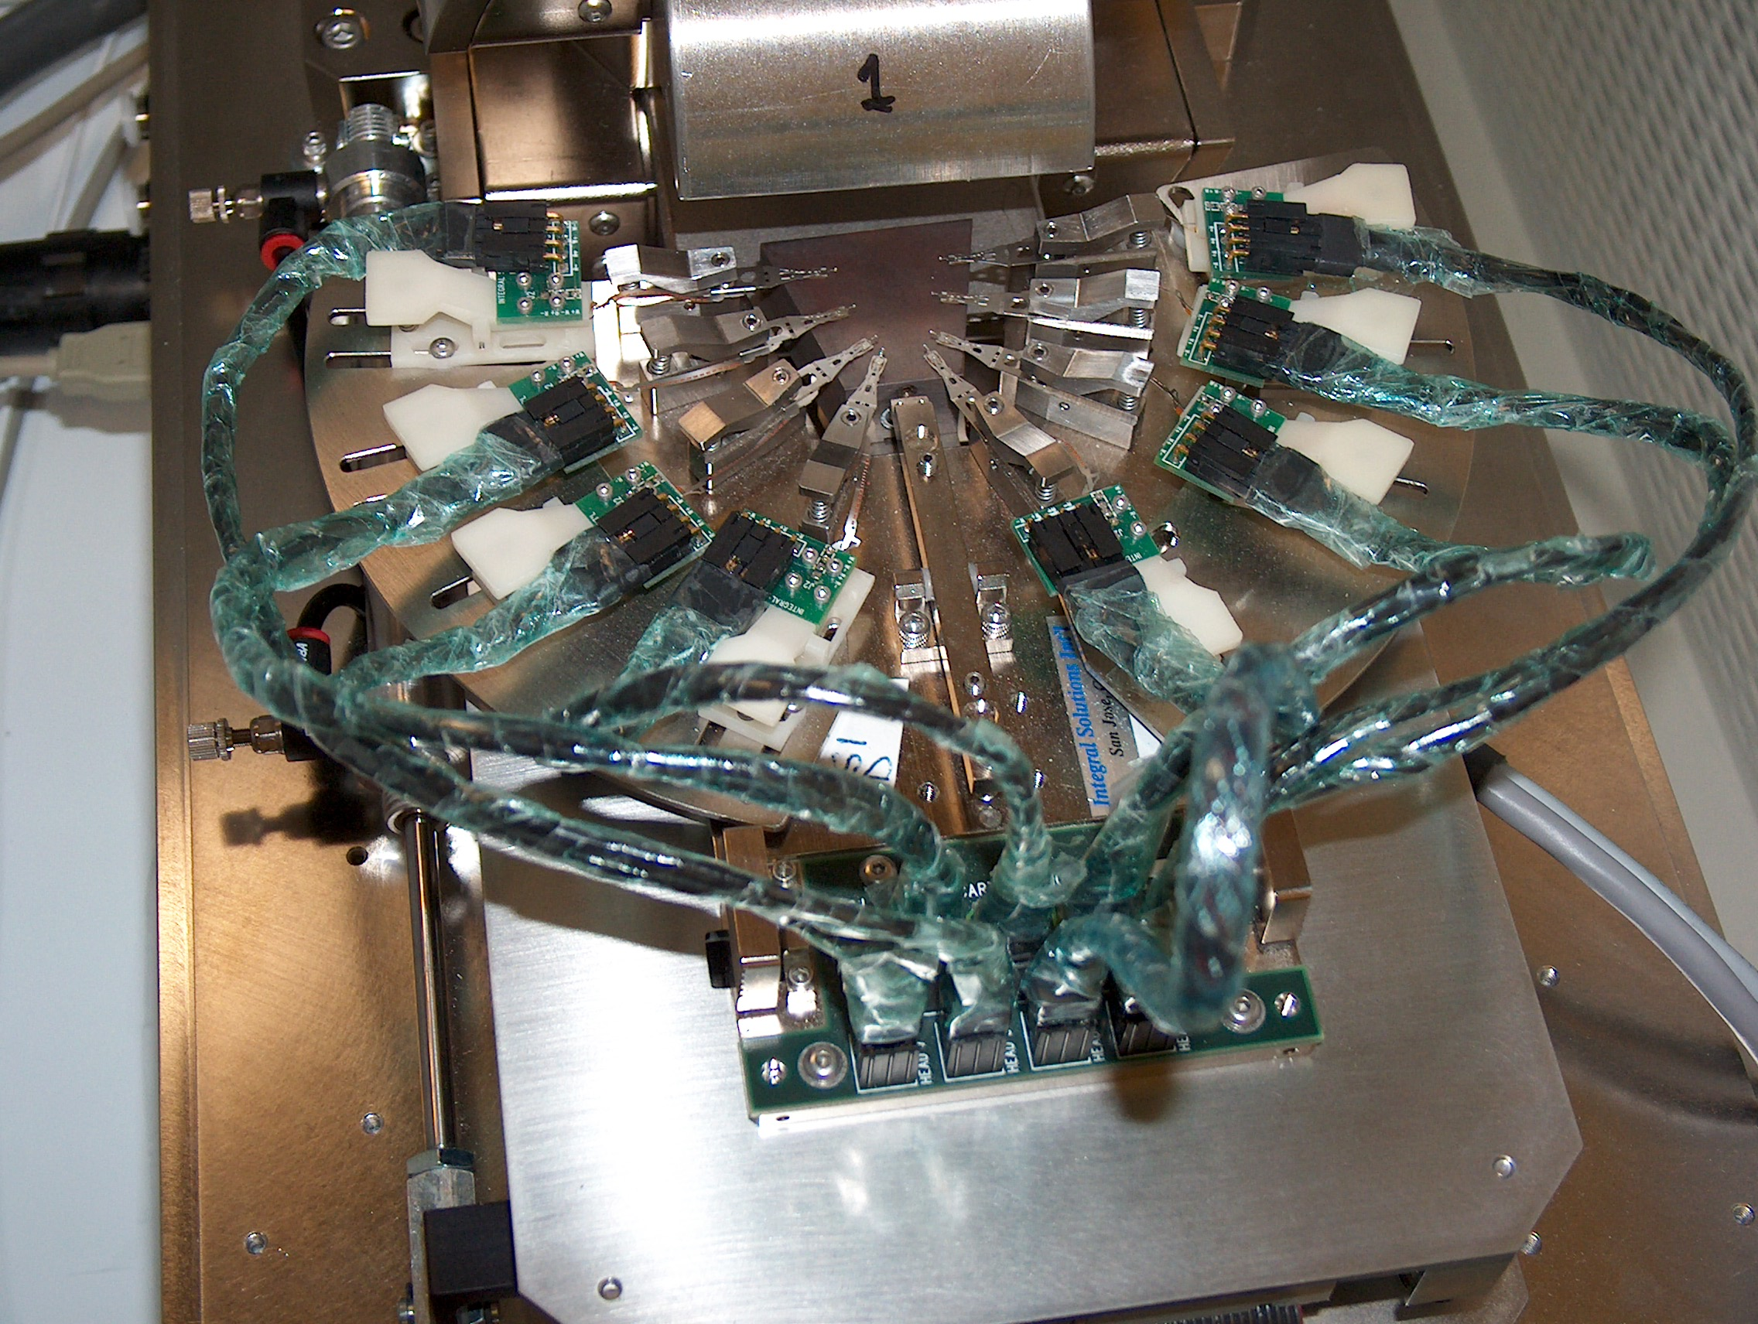
The R/W Heads and thermal assembly slide forward under the magnet in this 8 channel Desk Top version. Many other versions exist using the same Temp Control Subsystem some with air cooling. A 12 channel In-Line R/W Head Temperature Stress tool also uses this controller subsystem having a humidity control chamber and has temperature range of ~ -20° to 100°C.

