This is a later version of an SNP9000 undergoing some weekend construction. The motion stage is visible on the granite block. The nano-positioning sensing head (not shown) is fastened to the granite crossbeam above the stage. Directly above the sensing head and resting on the chamber enclosure top are X, Y, and Z Capacitive Distance Measurement Boards, also a RF Measurement Board.

To explain very briefly; the actual probe inspecting the photomask is a cylindrical piece of diamond ~120nm in diameter. It is mounted to a thin butterfly shaped piece of doped silicon ~ 1.5 cm^2 in surface area. At the butterfly shape center are two conductive magnetic balls either side. This elevating the wings and allowing some rotation of a few degrees, so one wing could be closer or farther from the supporting surface. This assembly would sit in a magnetic field attracting the magnetic balls which sit on small common conductive plates. Under each wing is a larger plate providing electro-static coupling to the silicon wings. With the silicon wings charged with ~40V; providing corresponding opposite voltages to the stationary plates would electro-statically control the wing rotation on the balls. Servoing the proper voltages to the opposite plates would balance the wings equal-distance above the supportive surface. The small diamond probe is bonded to the end of one wing on a small extension. If the assembly is brought into contact with a surface, the electro-static balance is disturbed. The RF Measurement Board would detect and output this signal and provide the servo and bias voltages needed to maintain the electro-static balance. A nano-positioning flexure assembly under computer control would raster the probe assembly over the work surface. CD measurement was through Distance Measurement Boards providing a voltage proportional to distance.

Adjacent the probe chamber is the equipment rack with AC Mains Interlock, UPS, Dual Computer subsystem, Auxiliary subsystem, Motion subsystem, Queensgate Nano-Flexure
Controller, and Precision DAQ subsystem. That’s me next to the equipment rack.
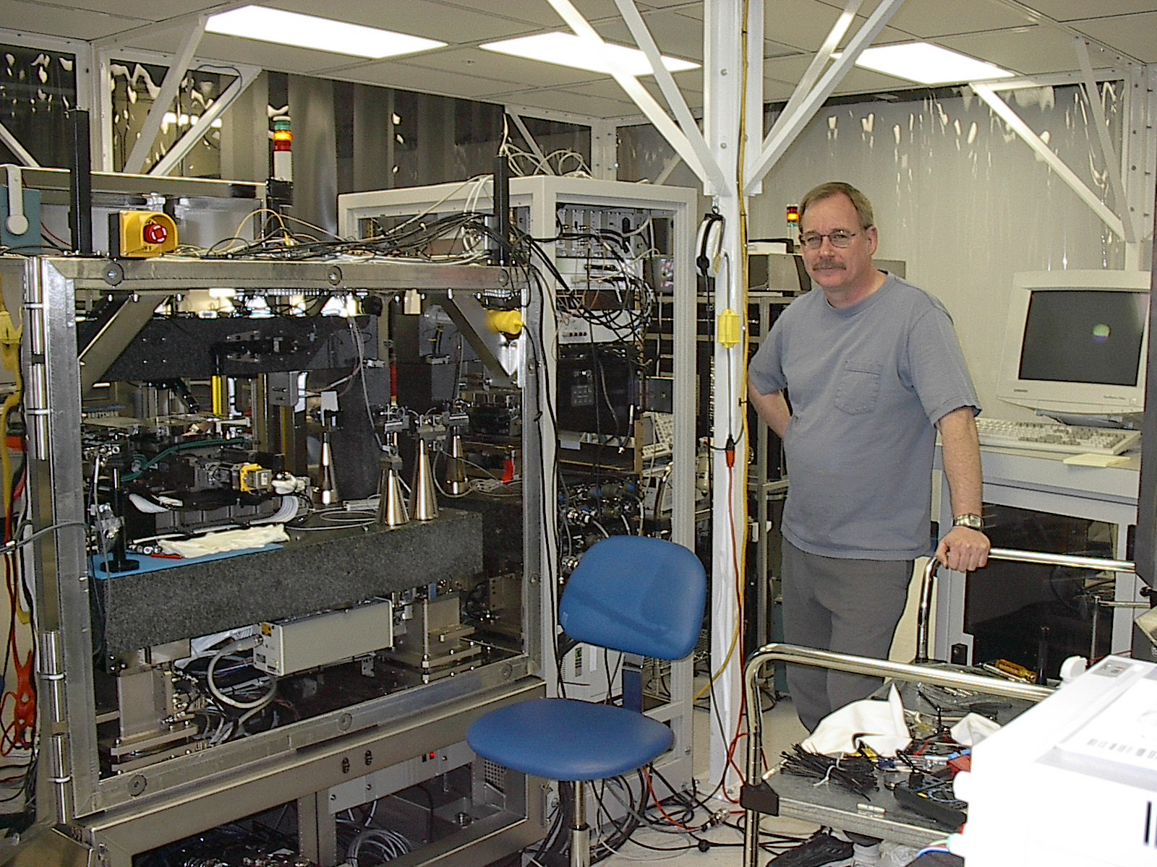
There aren’t many pictures from FEI Company. This is a Distance Measurement Board I designed. It uses thru-hole components since they are so much more thermally stable. Notice the big silver mica caps for low dielectric absorbtion, low ESR, low inductance, and temperature stability.
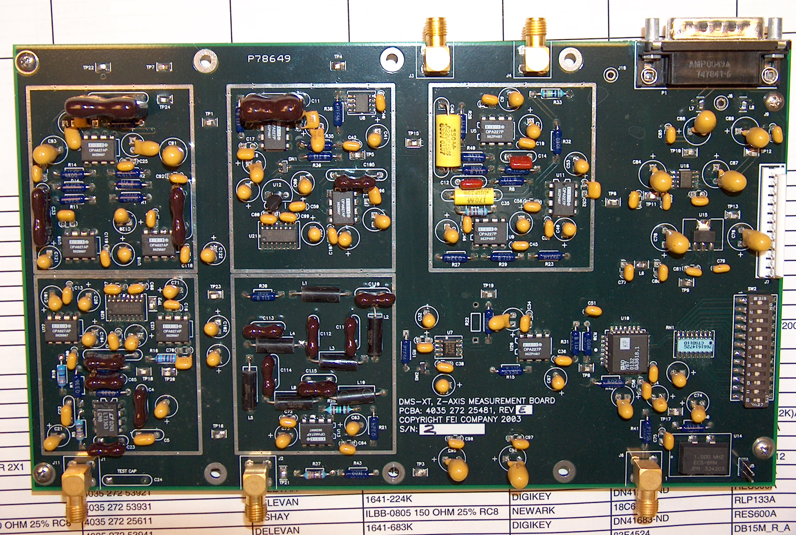

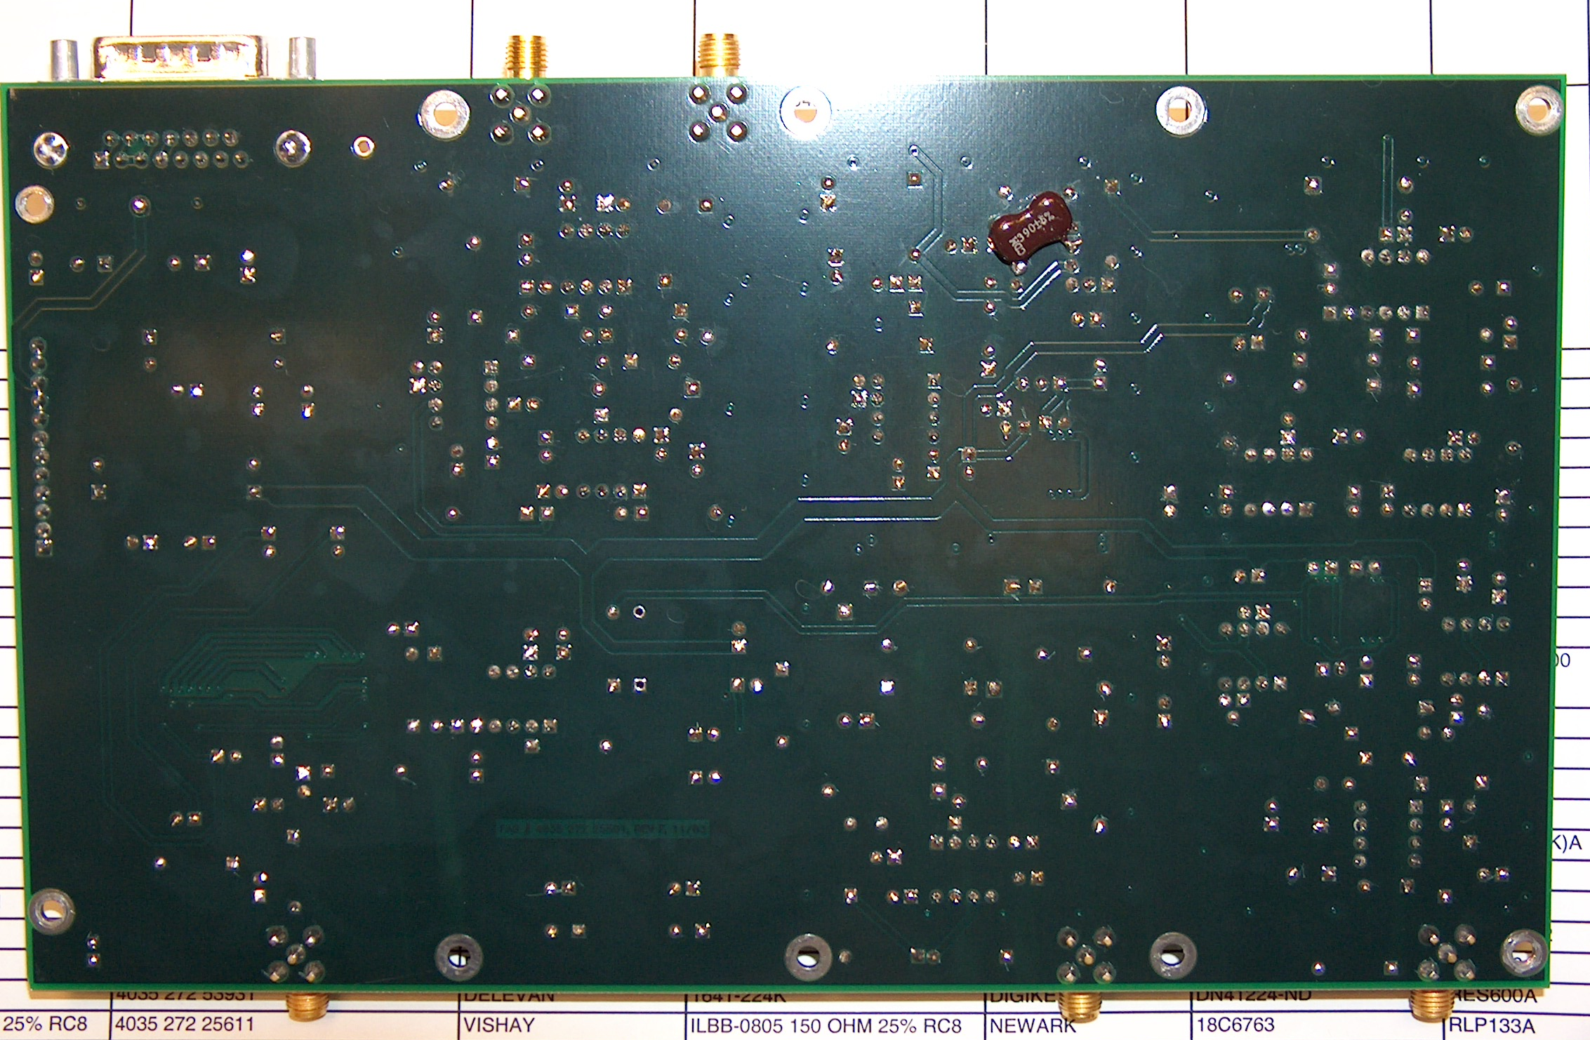

Here is a partially complete Motion Control Subsystem
