Here is a photo of the PCI End Point Bridge I debugged and wrote code for. An outside consultant and the chief engineer designed and did the board layout. This is an early revision, but not the earliest.
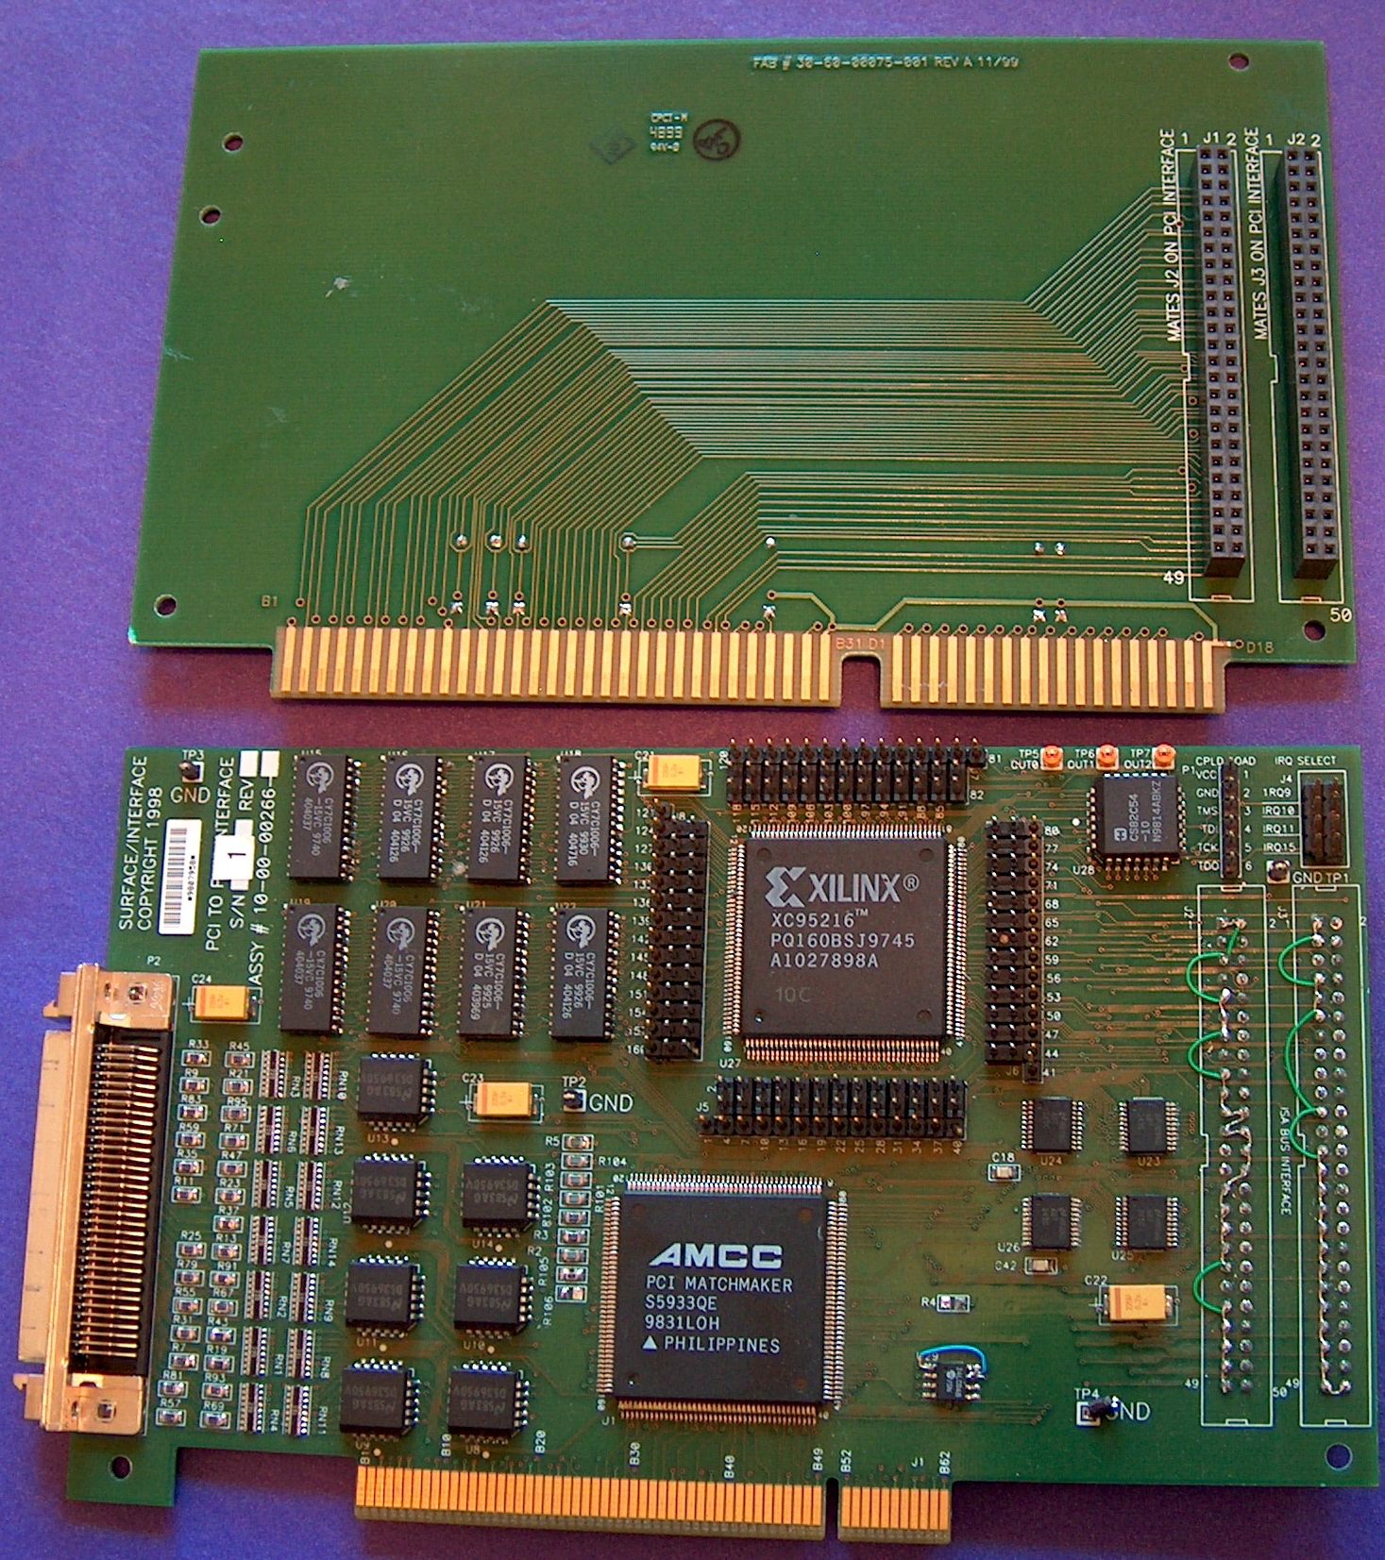
This board set allowed high speed communications between a PCI bus PC and an ISA bus PC. The boards would sit adjacent each other and be connected by the dual row socket connectors. The SCSI 3 cable connector facilitates a 23 channel differential pair communications link to a remote DAQ sub-system containing many 16 bit ADC and DAC boards. The ISA side had a P4 processor and was in more direct contact with the DAQ sub-system. The PCI side under WINNT communicated with the user.

Communication between the Single Board Computers was through the PCI Matchmaker device with many mailboxes, FIFO’s, and add on user bus etc. This board set also had 1MB dual port memory and a timer. Digital glue logic was through the CPLD. The main board was plagued with solder bridges and opens resulting in a very poor turn on rate and lots of intermittent failures. The provided test software just did not adequately test the board set. Also there was no test software to exercise or qualify any of the DAQ boards. I wrote 3 programs to test everything and you can look at them and others here.

